Gum Paste and Fondant Student Supplies
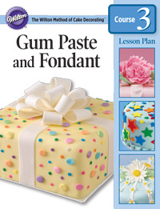
What to bring to Lesson 1
- Gum Paste and Fondant Student Kit
- 1 Wilton Ready-To-Use Fondant (24 oz)
- 1 Ready -To-Use Gum Paste
- Roll & Cut Mat
- Practice Board
- 9” Rolling Pin with Spacer Rings
- Tapered or Angled Spatula
- Rolling Pin (Wilton 20” preferred)
- Yellow Sparkling Sugar
- Styrofoam cup
- Facial tissue
- Box to take home bow (at least 8 inches square and 4 inches high)
- Scissors
- Corsage pin
- Small amount of white vegetable shortening
- Damp cloth
- 25 Napkins or paper towels
- 6 gallon-size plastic zipper food storage bags
- 6 quart-size plastic zipper food storage bags
- 1 tablespoon cornstarch
- 1 tablespoon powdered sugar
- Glue stick, repositionable preferred
- Thick spaghetti (#5 is best)
- Small container with about 1/4 cup water
- Small container with a tight-fitting lid for gum-glue adhesive

